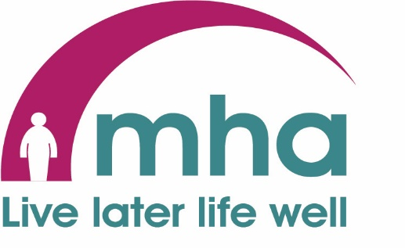
Neston Wellbeing Support Services.
Every Wednesday. Doors open 10am.
Churchill Court Communal Room CH64 3TY

Wellbeing Activity Group. 10.30am to 12noon
This is an activity for people interested in being active in the natural environment. Activities are designed for all levels of physical being. You can immerse yourself totally or just sit, watch and enjoy the environment or engage in a light mindful activity or create things for your personal environment. We will give tips on how to appreciate and enjoy the natural environment in your home and community, and where to seek solace in nature locally. There is a charge of £3 per session to cover small costs.

Soup & Sandwich Social Session. 12noon to 1pm
Drop in and enjoy a chat over a mug of freshly made soup with a sandwich. Meet our team and make new friends. There is a small charge of £1.

Dementia Support Group. 1.30pm to 3pm
This is a group that provides support to people living with dementia and their carers. The group will provide a variety of member led activities to engage the loved one and support the carer. Attendance is with the carer or a relative. There is a small charge for some activities.

Mental Wellbeing Service.
This is a floating service available to anyone suffering from such issues as anxiety, depression, loneliness, low mood or anything that is affecting a person’s mental wellbeing. We provide a consultation to discuss with you in private any issues you wish to address so that we can assess your needs and understand how we can help you.
This is a FREE and Confidential Service.
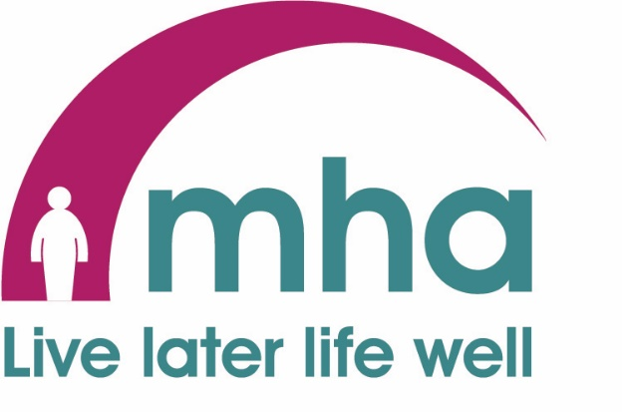

MHA COMMUNITIES CHESHIRE WEST

Our contact details;

Main Office: 0151 357 3873. The office is only manned part time. 24/7 answerphone service. Please leave a message and we will return your call as soon as is possible. Alternatively you can use the following contact details.

Email: cheshirewest@mha.org.uk

David: 0793 520 2562. Email: david.foulds@mha.org.uk

Facebook: www.facebook.cheshire.west

